Minnesota Juvenile Officers Association
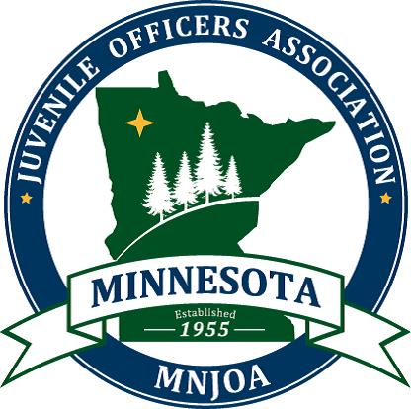
Year: 2020
Annual Awards Nomination Form

Outstanding Juvenile Officer (sworn)
Pam Taschuk Outstanding Service Award (non-sworn)

OUTSTANDING JUVENILE OFFICER
This award is given to an outstanding Peace Officer, as determined by the awards committee, who specializes in working with youth in Minnesota. The following criteria may be considered in determining the award recipient.
- Must be a licensed peace officer in good standing with the MN Peace Officer Standards and Training Board.
- Must have demonstrated above and beyond the call of their regular assignment, their willingness to work toward the betterment of youth in Minnesota.
PAM TASCHUK OUTSTANDING SERVICE AWARD
This award is given to non-sworn nominees who specialize in working with youth. Both public and private entities, and/or individuals, may make nominations to the awards committee.

Nominee Information:
Name: __________________________________________ Phone: __________________________________________
Organization: __________________________________________ Email: __________________________________________
Address: __________________________________________ City: __________________________ Zip: ___________
Nominated by:
Name: __________________________________________ Phone: __________________________________________
Organization: __________________________________________ Email: __________________________________________
Address: __________________________________________ City: __________________________ Zip: ___________

Directions for Submission:
Attach a written statement of why the nominee should receive the award, considering the following statements.
Please submit with the appropriate documentation, letters of recommendation, etc.
- How has the nominee provided support to the community by bridging organizations such as law enforcement, schools, and families?
- Role models are people who inspire greatness in others and nominees for this award must represent just this. Please show an example of how the nominee demonstrated being a positive role model.
- It is important for a nominee to have demonstrated necessary skills to build positive relationships with the kids they are working with. How has the nominee gone above and beyond to build relationships with kids who are struggling (at school, at home, with friends, etc.)?

Nominations Must Be Received No Later Than January 1st. The winning nominee(s) will be notified of their selection during the first two weeks of January prior to the annual conference, and they will be invited to attend the annual conference to receive the award.

All completed nomination forms should be submitted to:
Minnesota Juvenile Officers Association If possible, email submission is preferred to:
4838 187th Ct. W., Farmington, MN 55024 suzyd857@charter.net
Questions ~ Please contact Suzanne Dau at (651) 249-5619

